AWS Training :

IAAS -

PAAS - Only war file deployment

SAAS

#Root Account then n number of users

Services :

***Compute :***

#EC2 (IAAS) – OS

#Elastic Beanstalk (PAAS) – OS,Application Server, Deploy simple application, Java , PHP , python

#Lambda – Uploading File

***Storage :***

# S3 – store anything , daily back up, static website, Call as object

***Database :***

#Relational DB

#DynamoDB – no sql

***Networking & Computing :***

#VPC –

#Route 53 – Ip & Domain Name Mapping

Security , Identity

#IAM - Creating users & permission

***Developer Tools : j***

# Code commit :

Management Tools :

#Cloude watch : monitor / notification like CPU utilization 70%

Messaging :

# Simple Notification Service : Auto generated email

***Security , Identity***

#IAM - Creating users & permission (dtcc2) :

Services -> IAM 🡪 Groups 🡪 Admin 🡪

[https://aws-dtcc-123.signin.aws.amazon.com/console dtcc2](https://aws-dtcc-123.signin.aws.amazon.com/console%20dtcc2) : password123

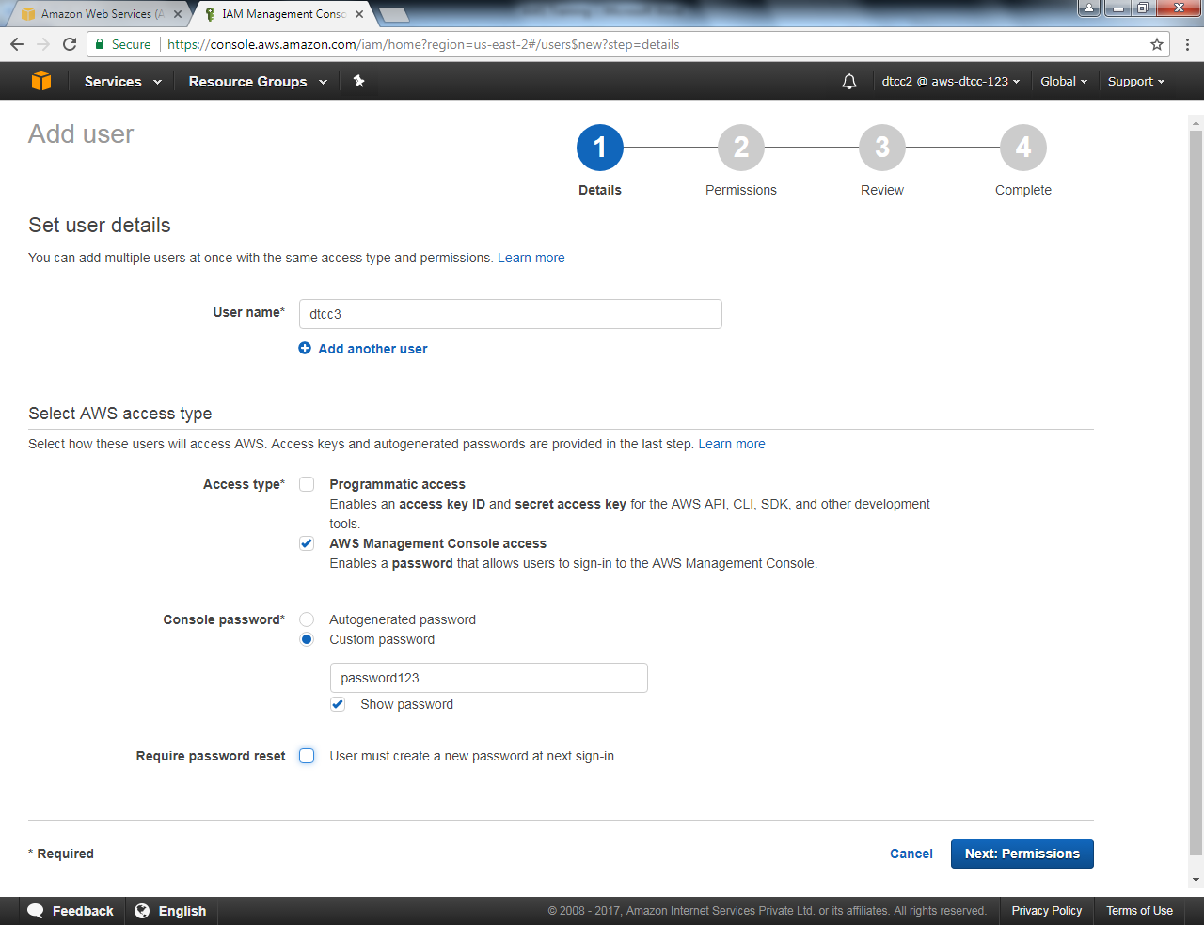

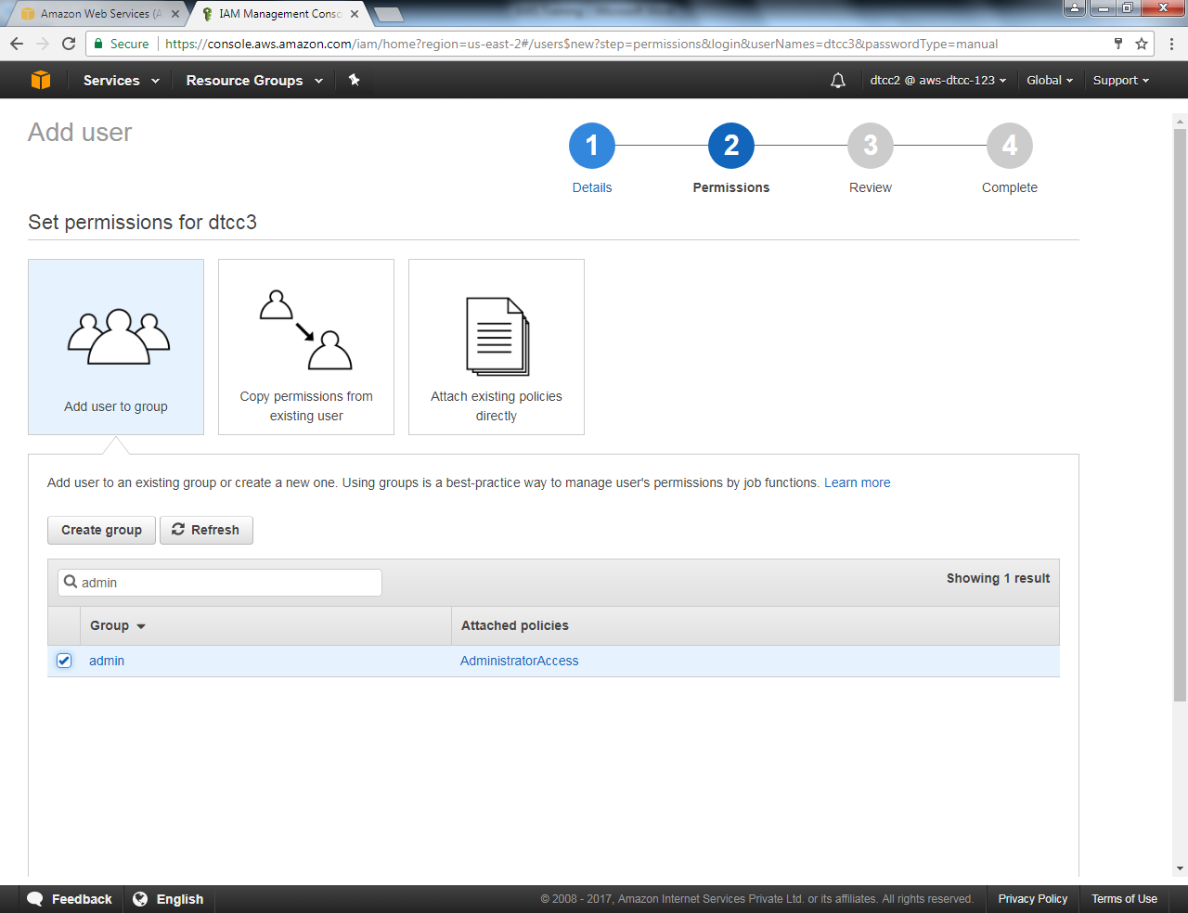

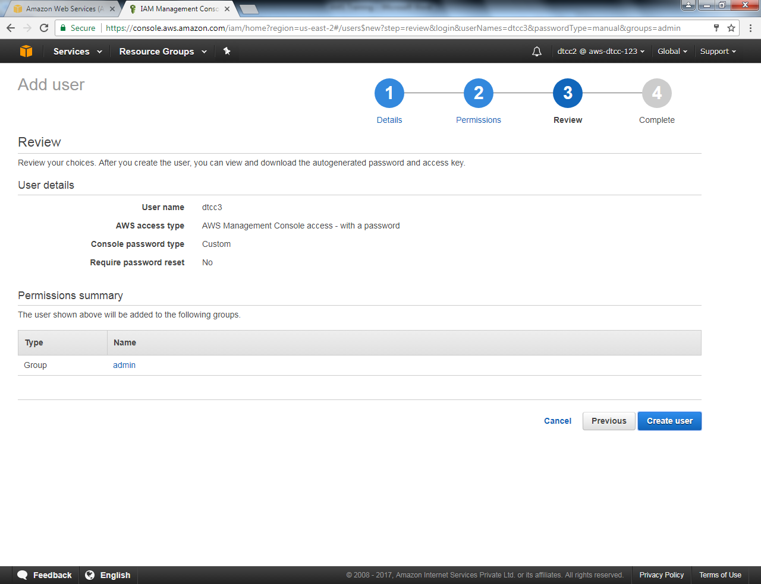

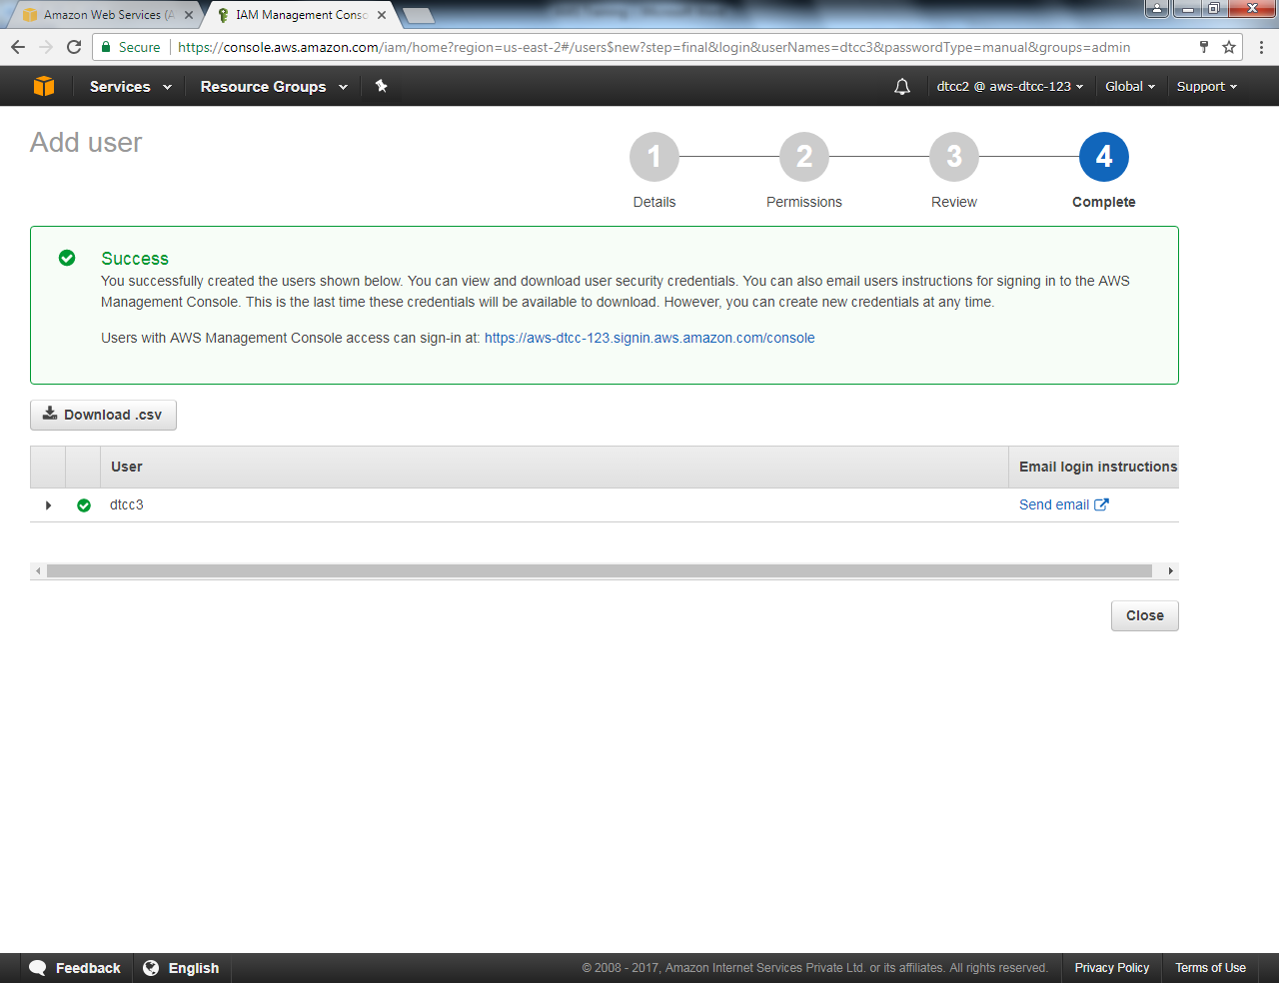

Sanjaydegaonkar

<https://github.com/sanjaydegaonkar/AWS>

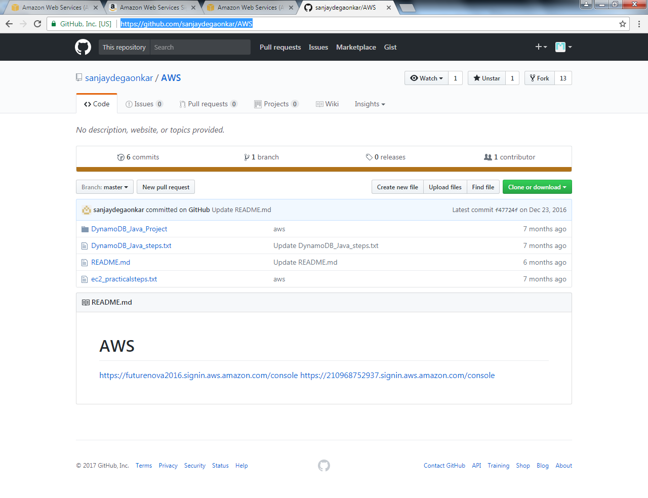

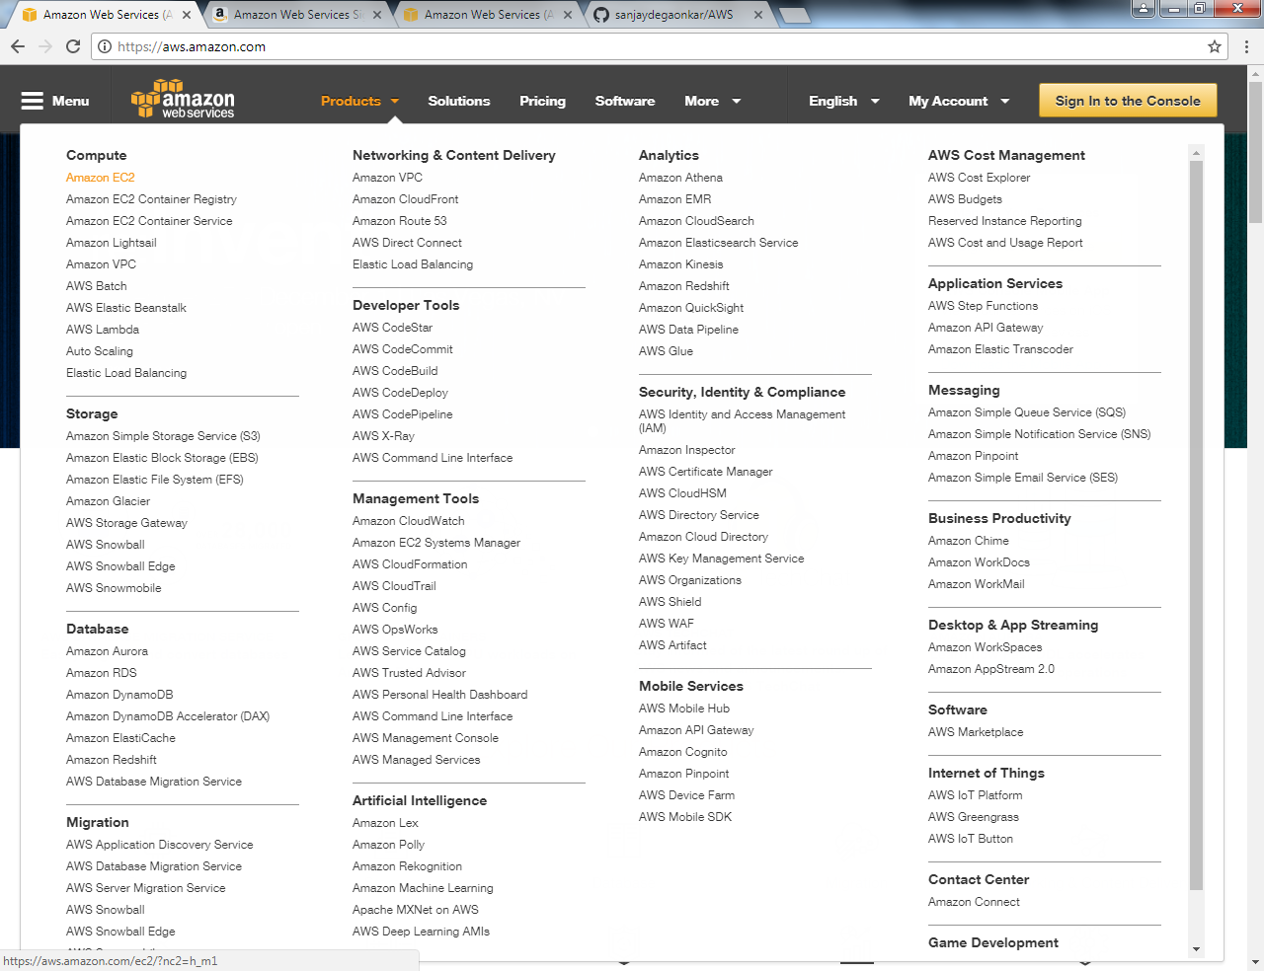

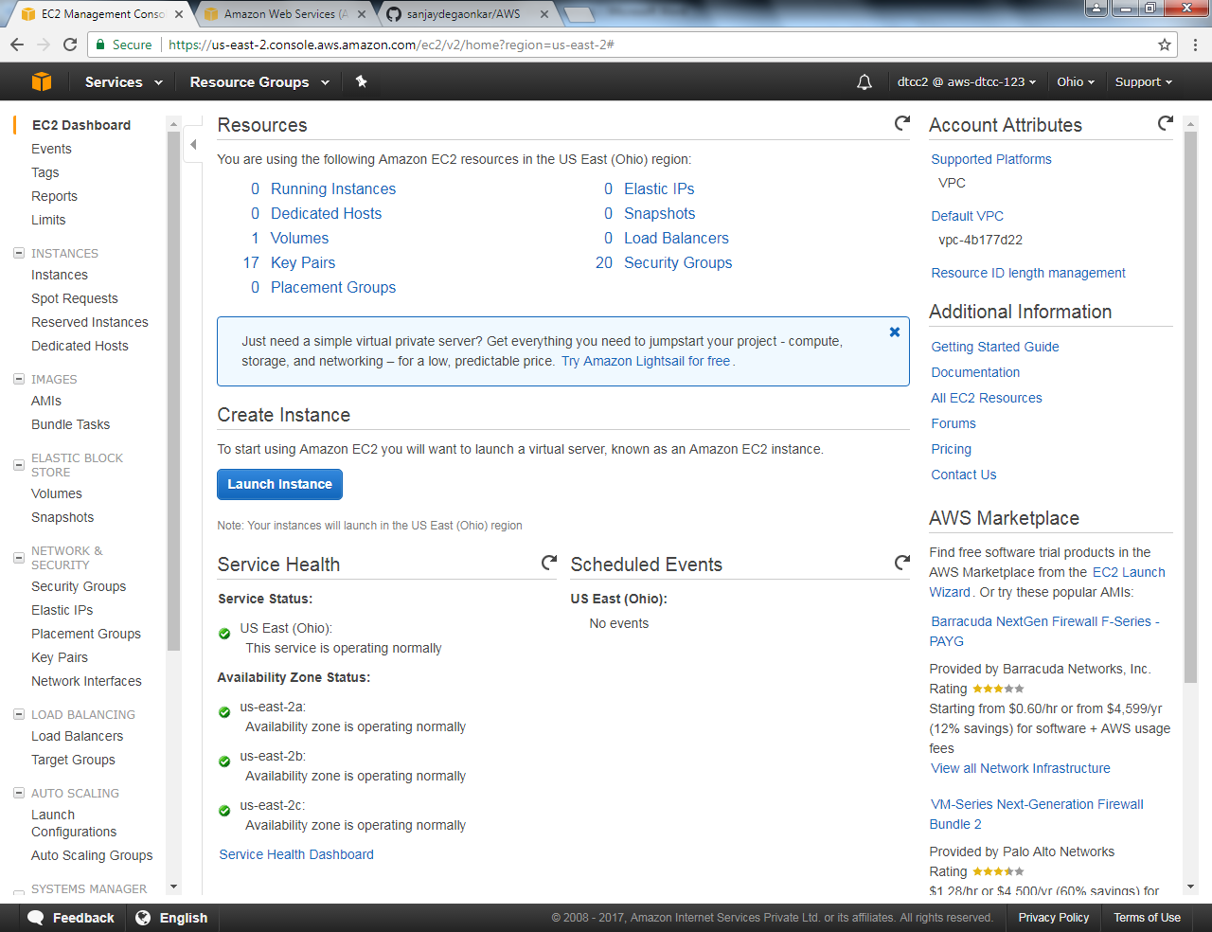

#Click on Launch Instance

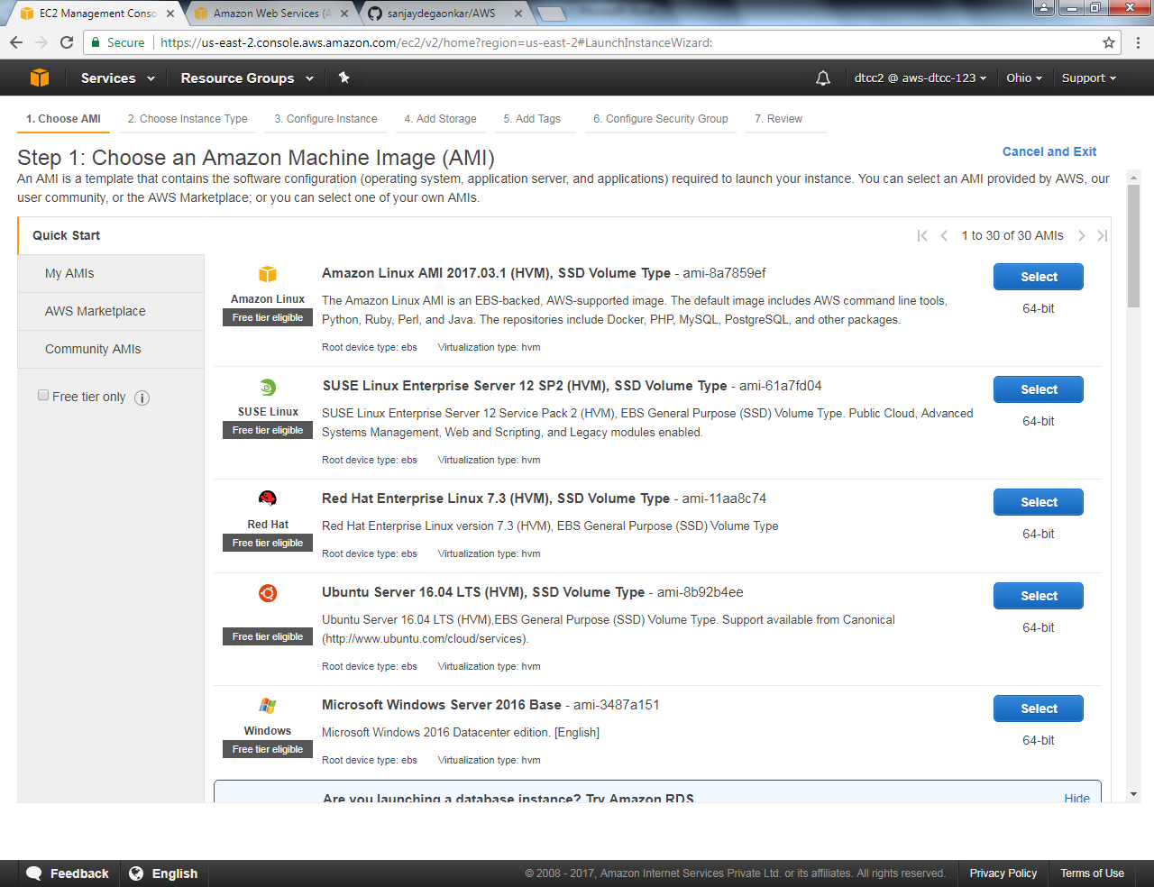

Select operating system

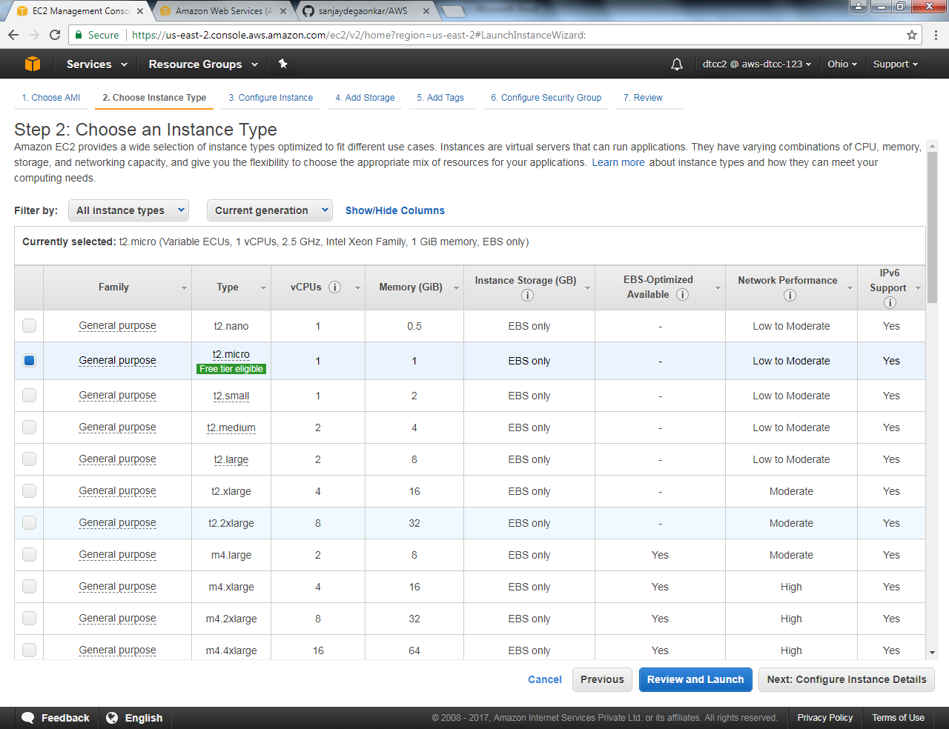

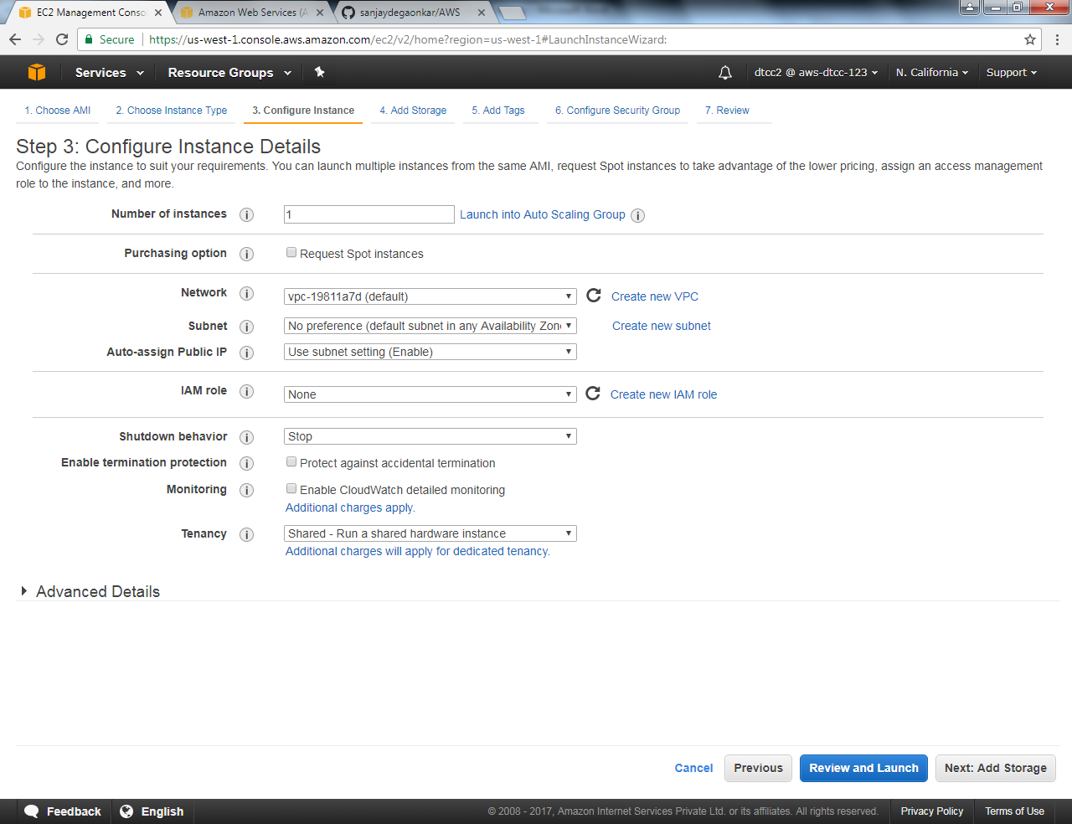

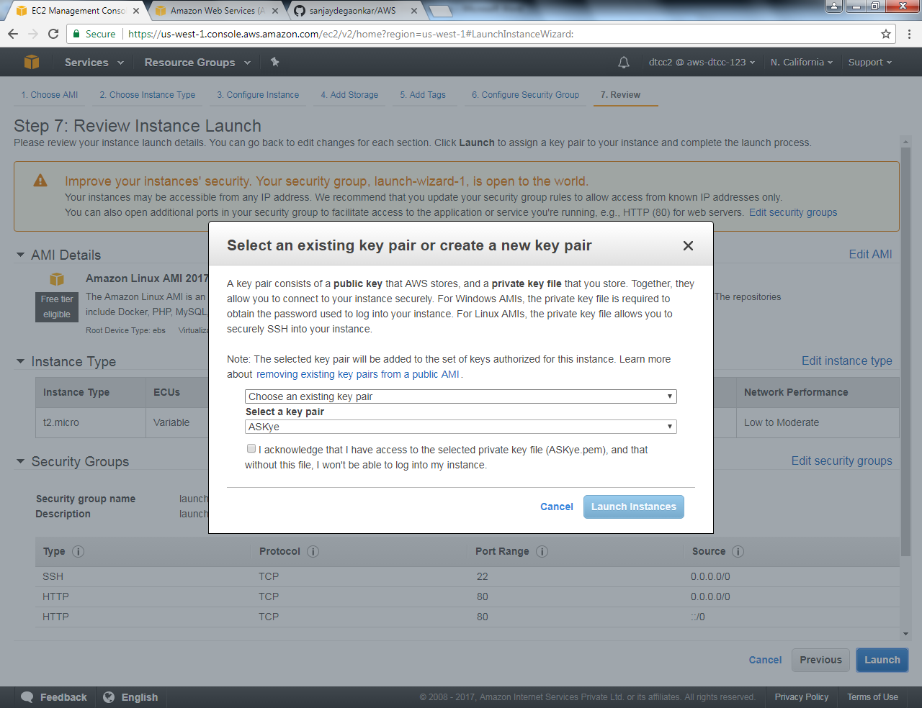

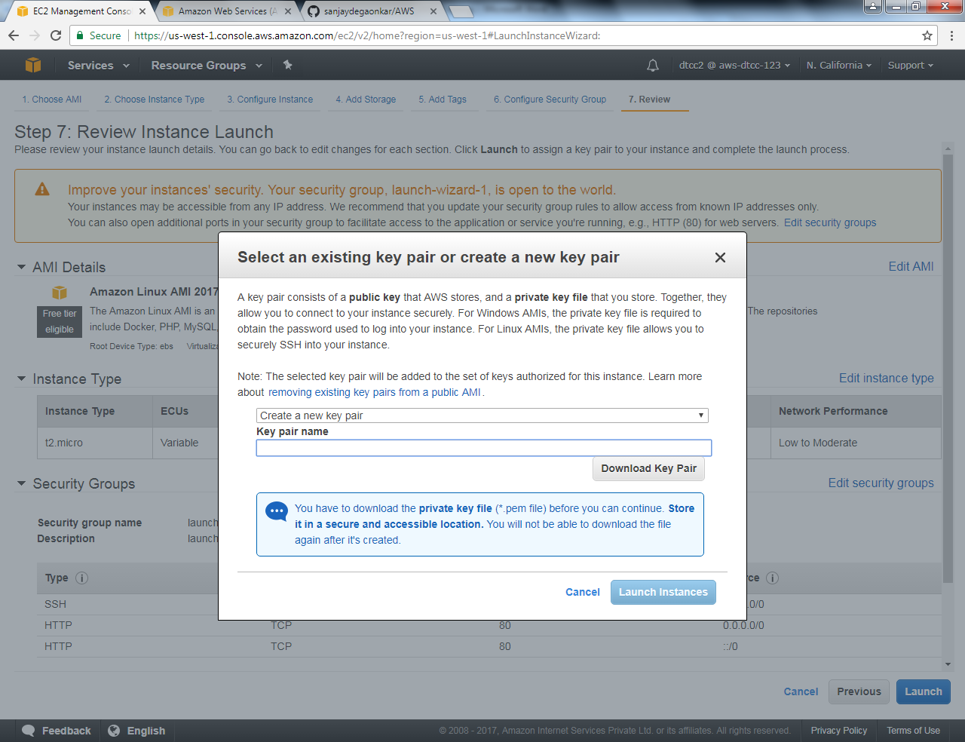

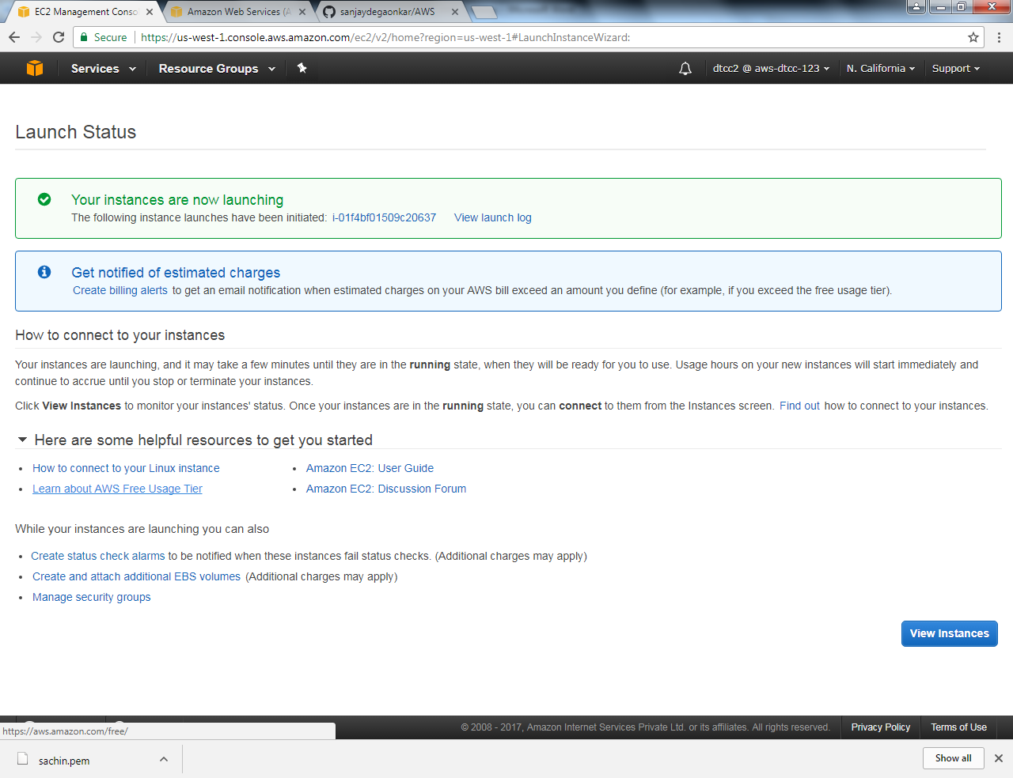

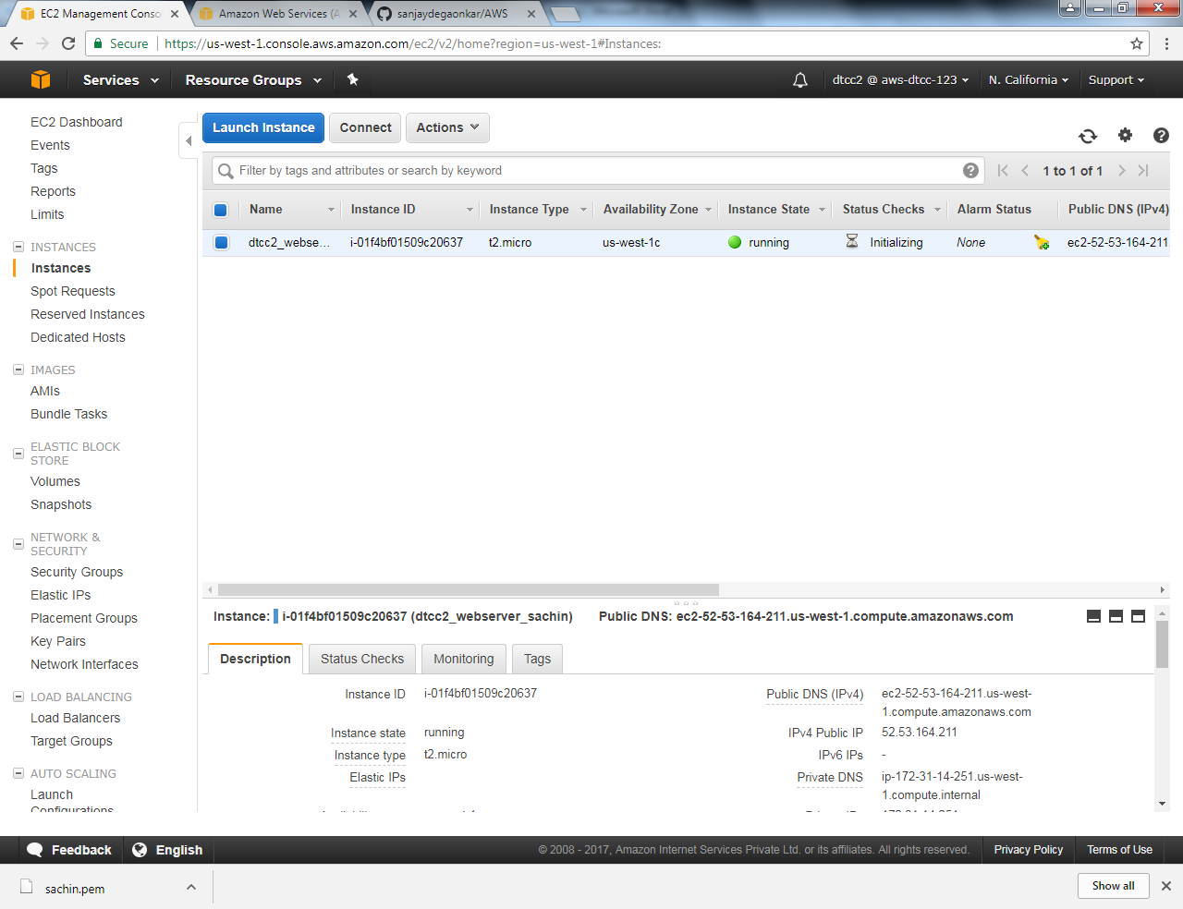

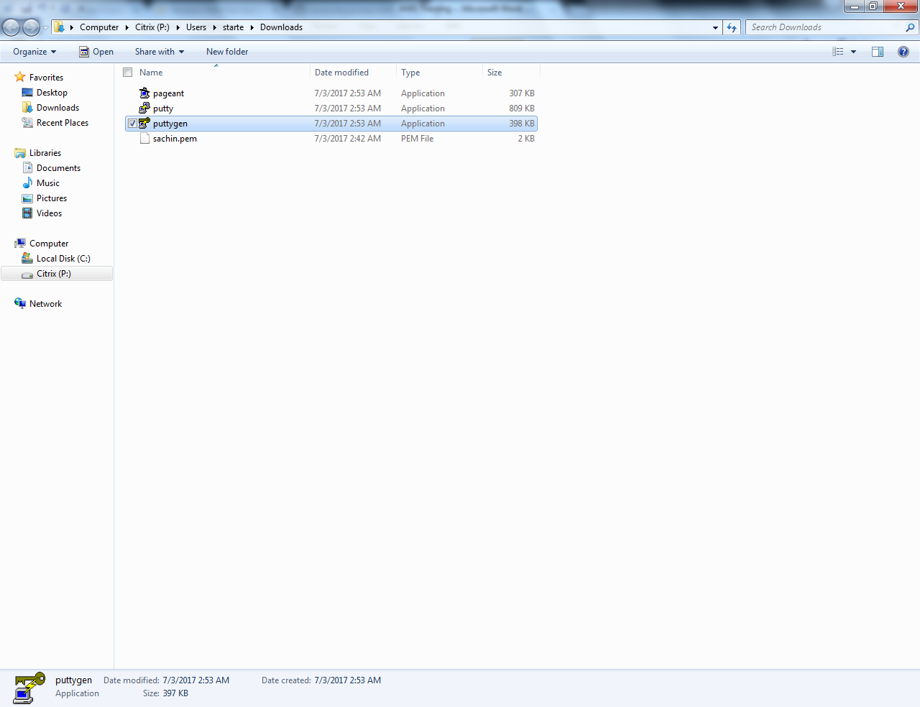

Launch Puttygen.exe

Load sachin.pgen & save private ppk file

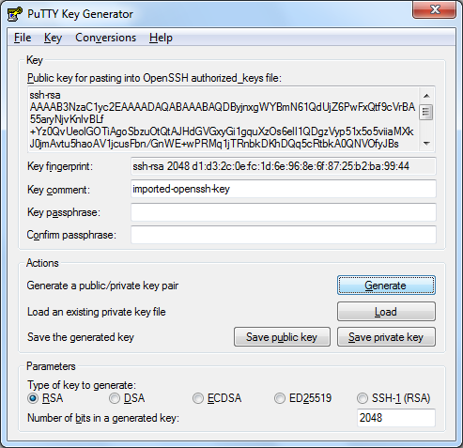

#Launch Putty.exe

Copy public ip add to launch Putty.exe

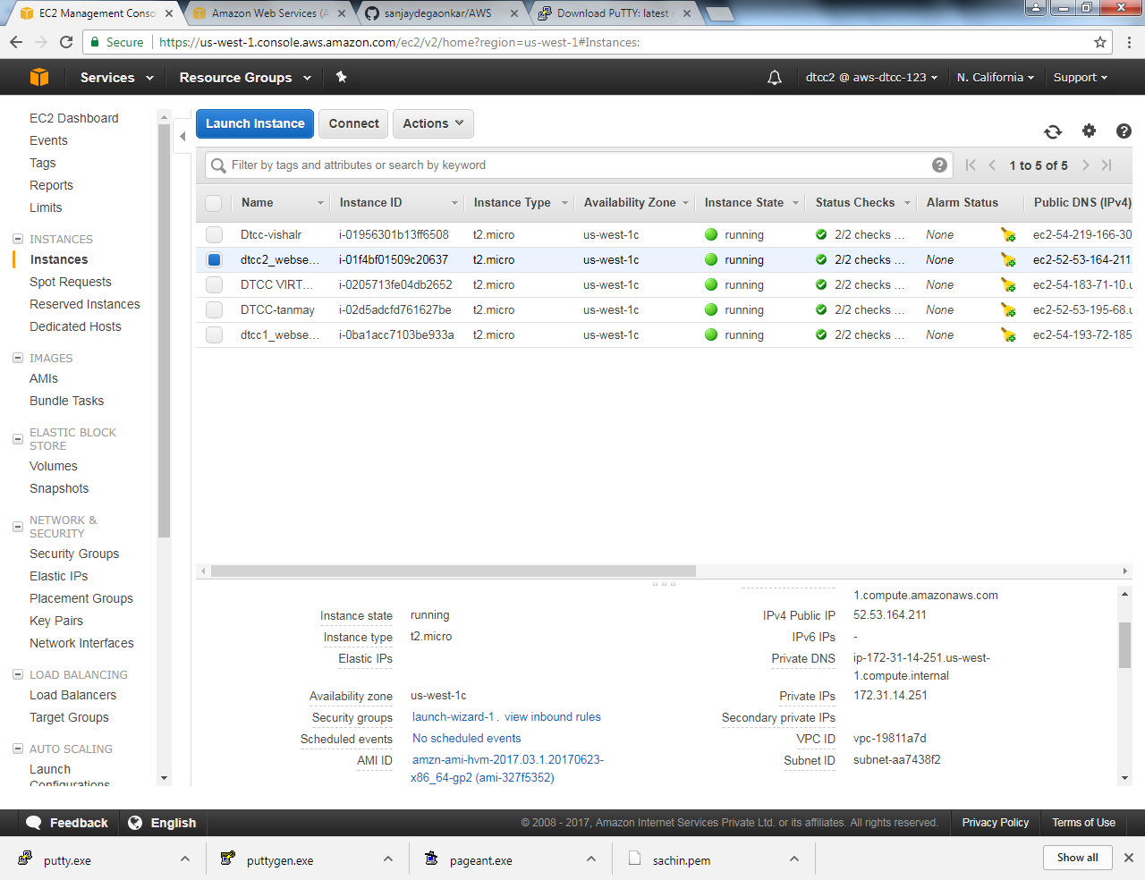

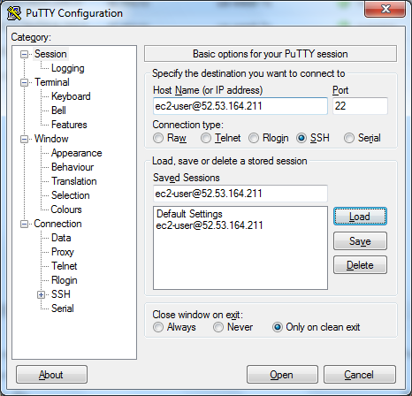

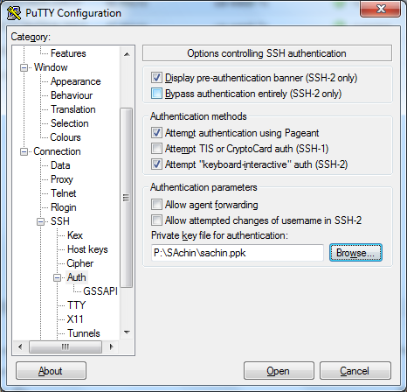

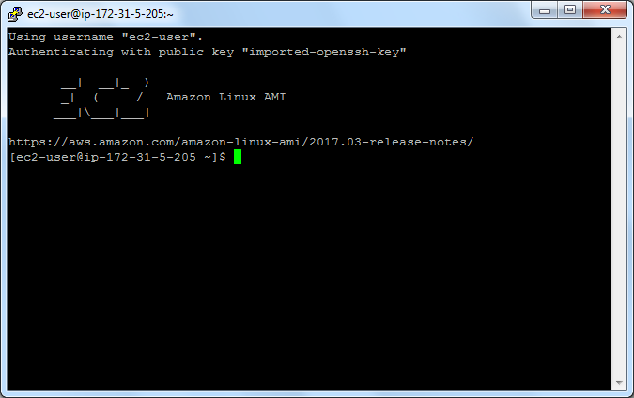

Install Java , Git,

Create Project using gradle

SAAS

Access Path \\arltrgsrv\LAB 8 - AWS

PAAS – Platform as a Service

# Deploy the Application – War file.

# AWS Service require # Elastic Beanstalk

# Deployment of Web Application .war file

# Create New Application 🡪 Create one now

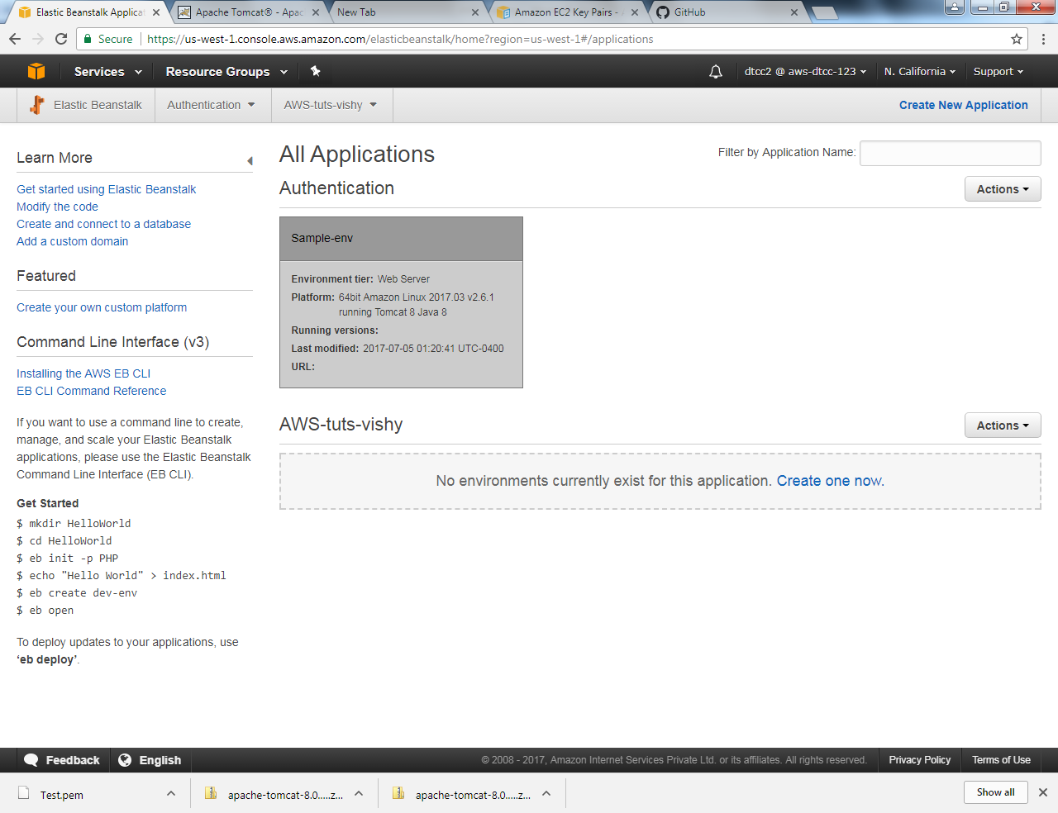

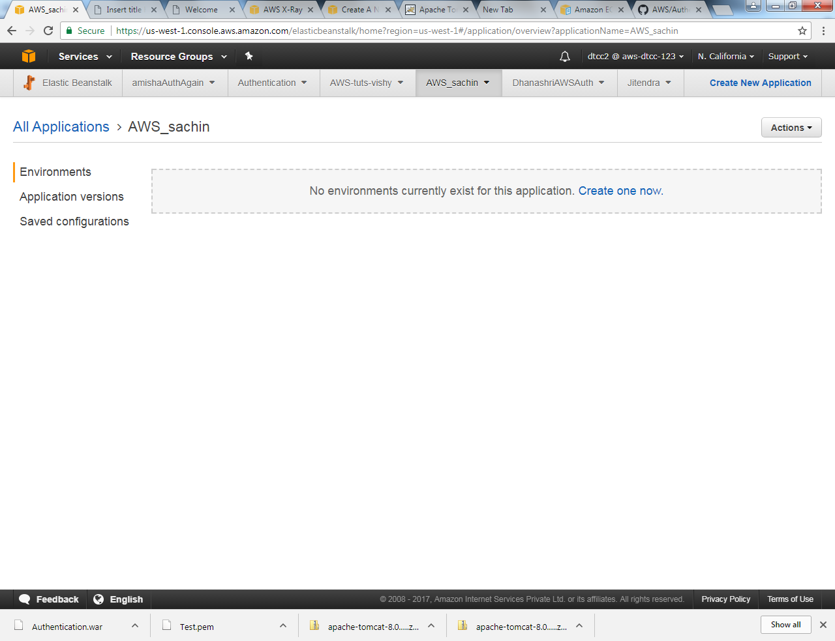

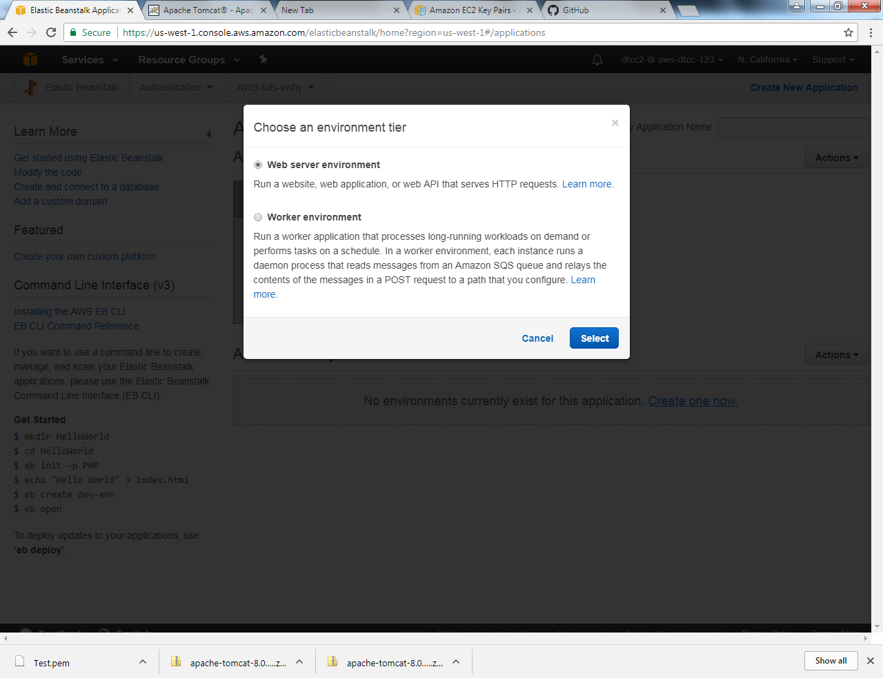

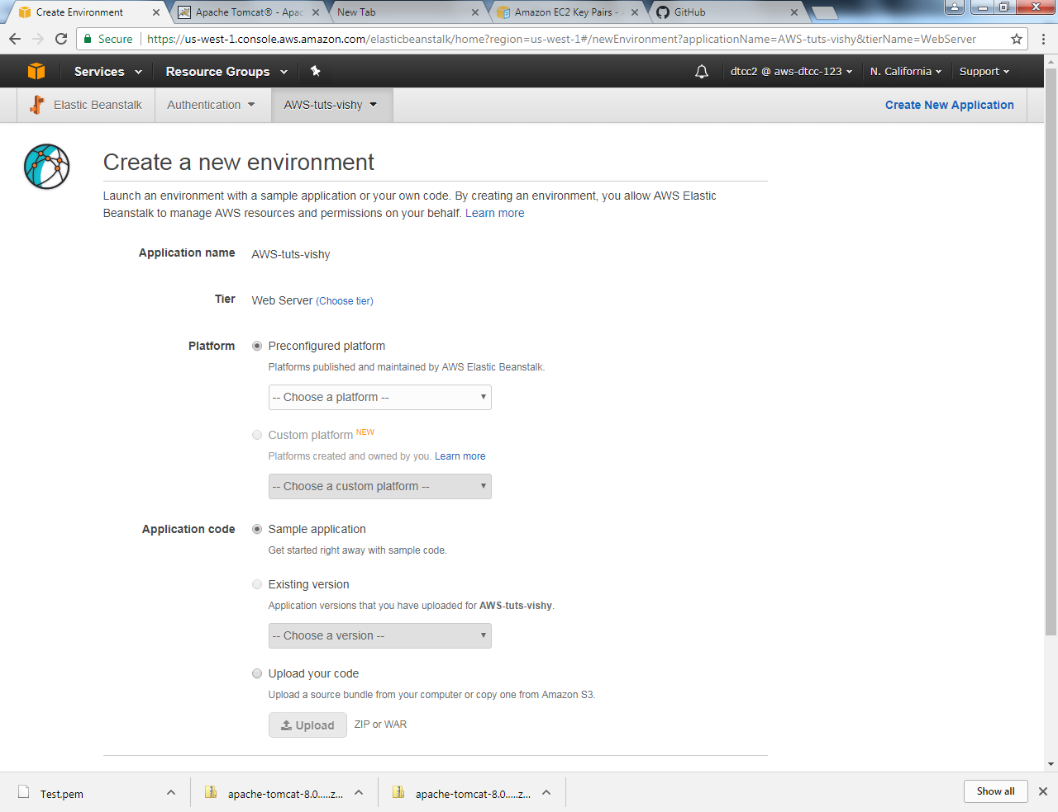

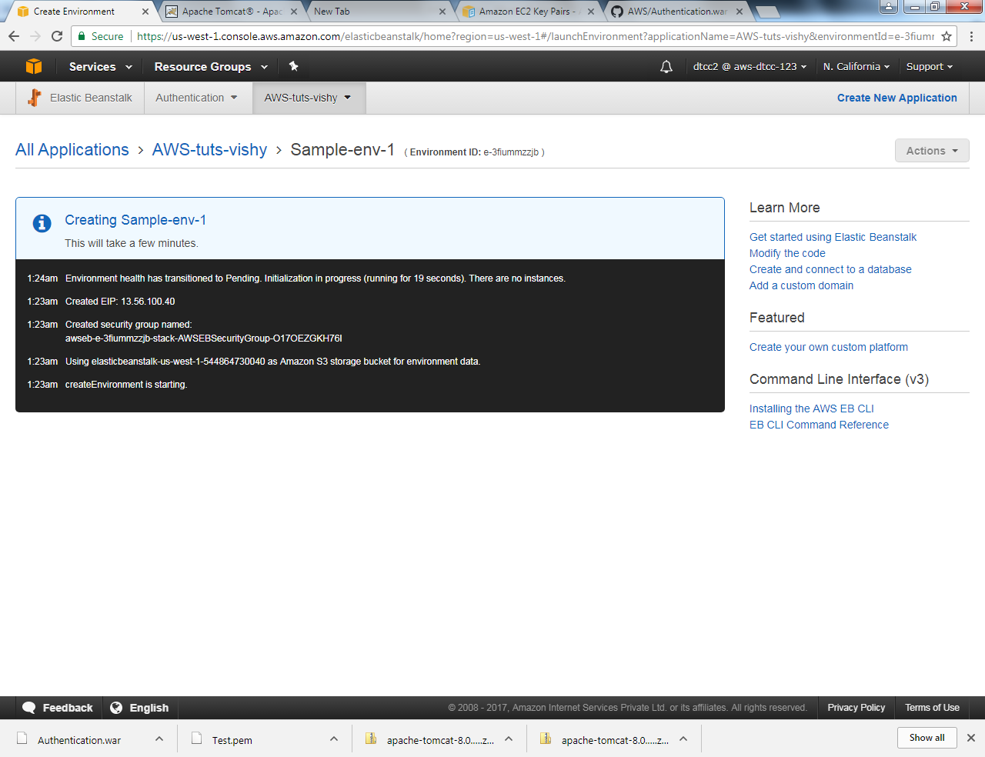

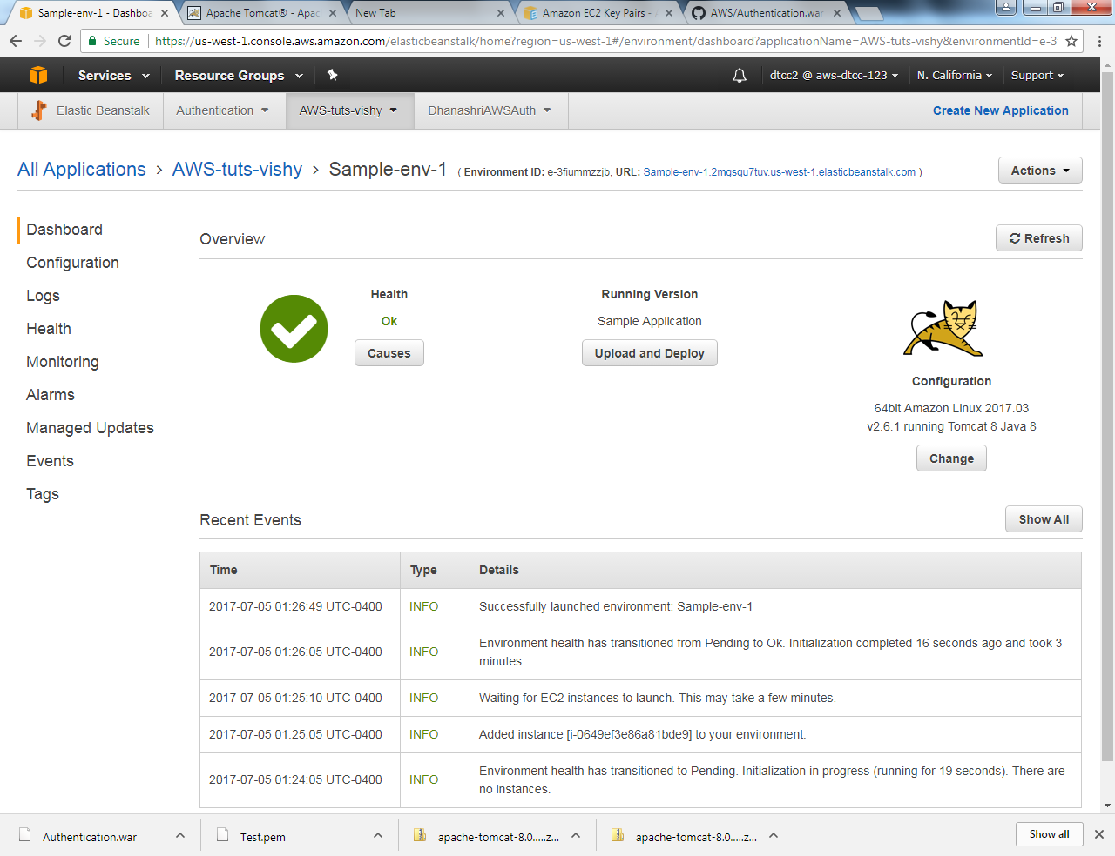

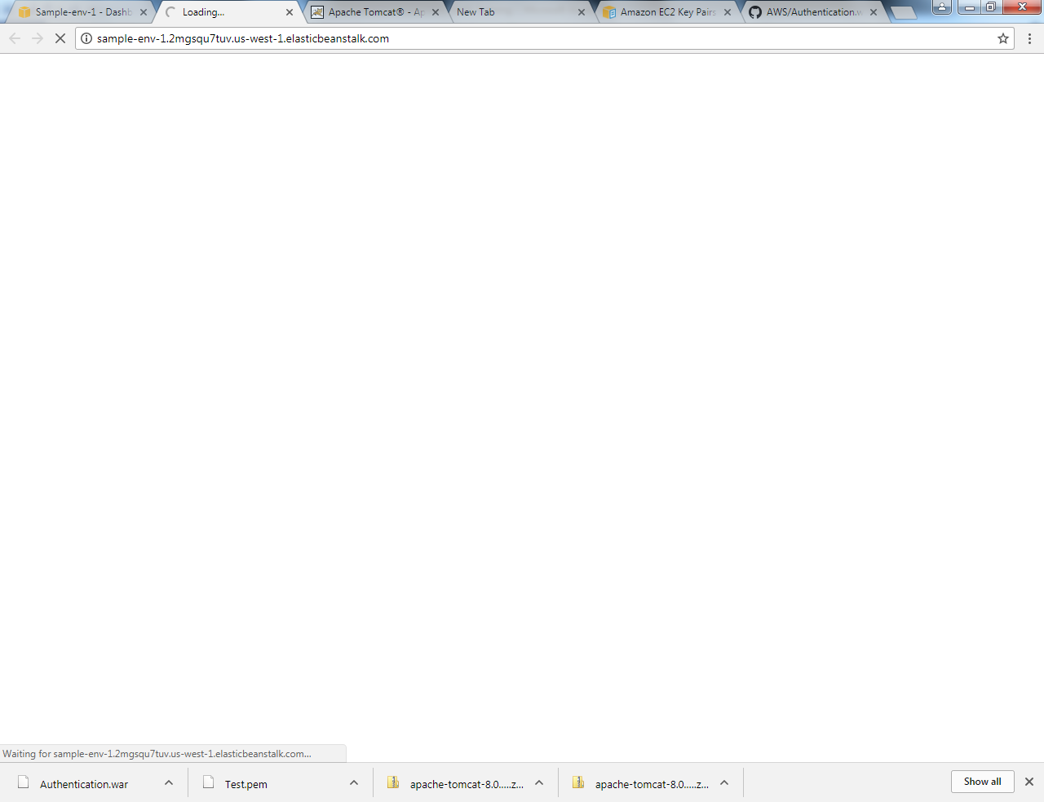

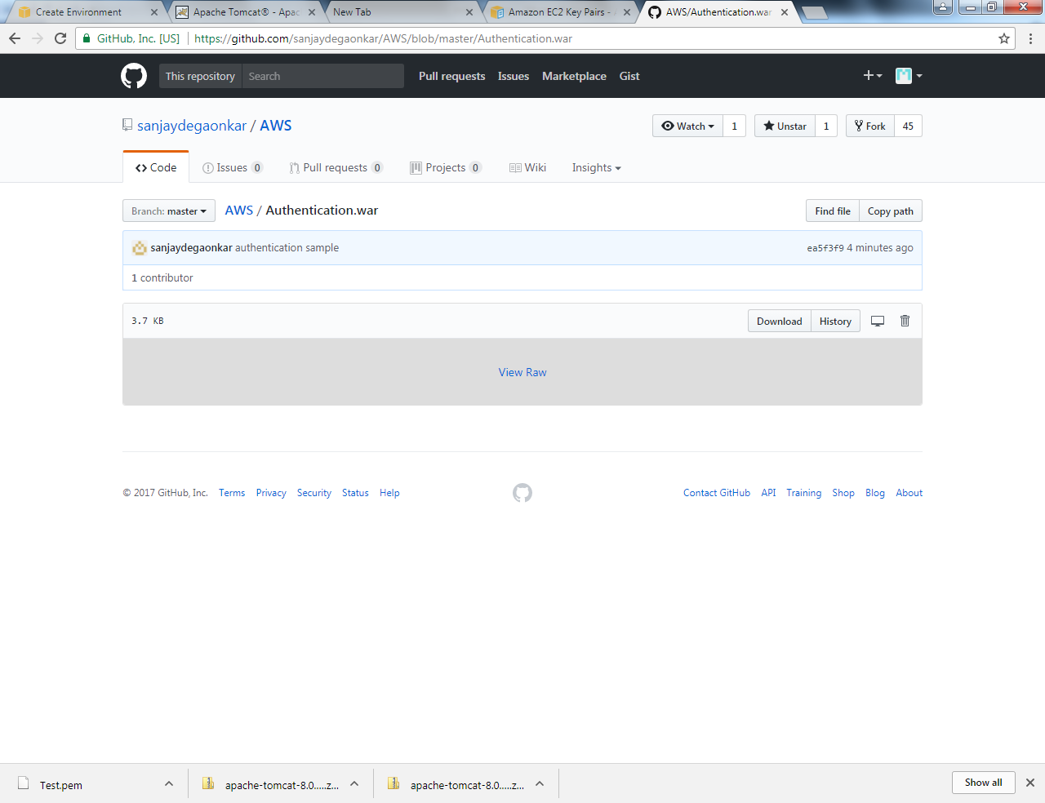

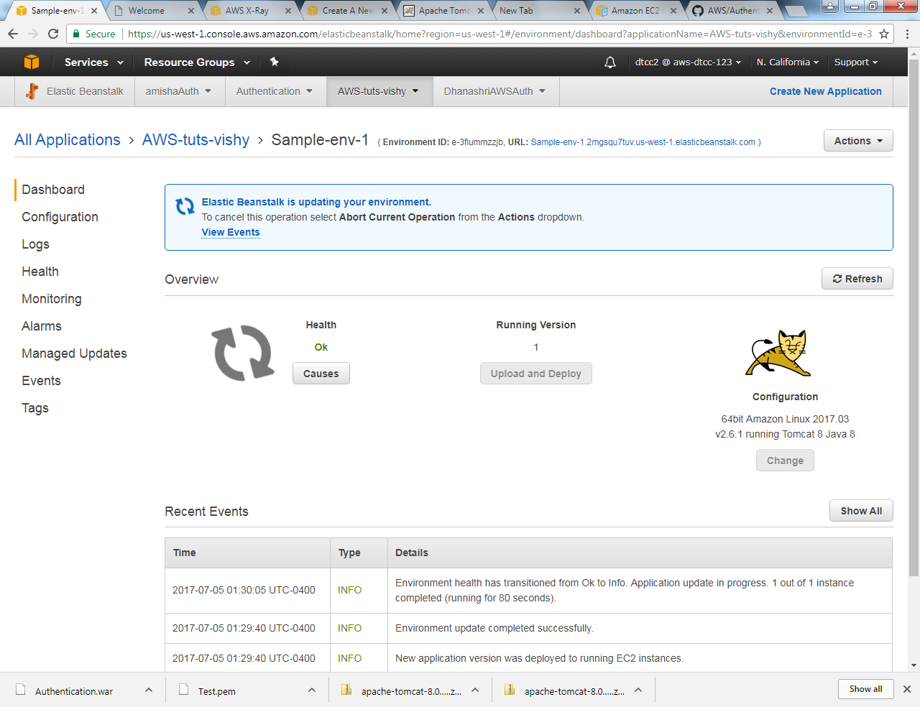

Link for Certification :

\\10.207.173.45\Softwares\AWS_Videos

SAAS

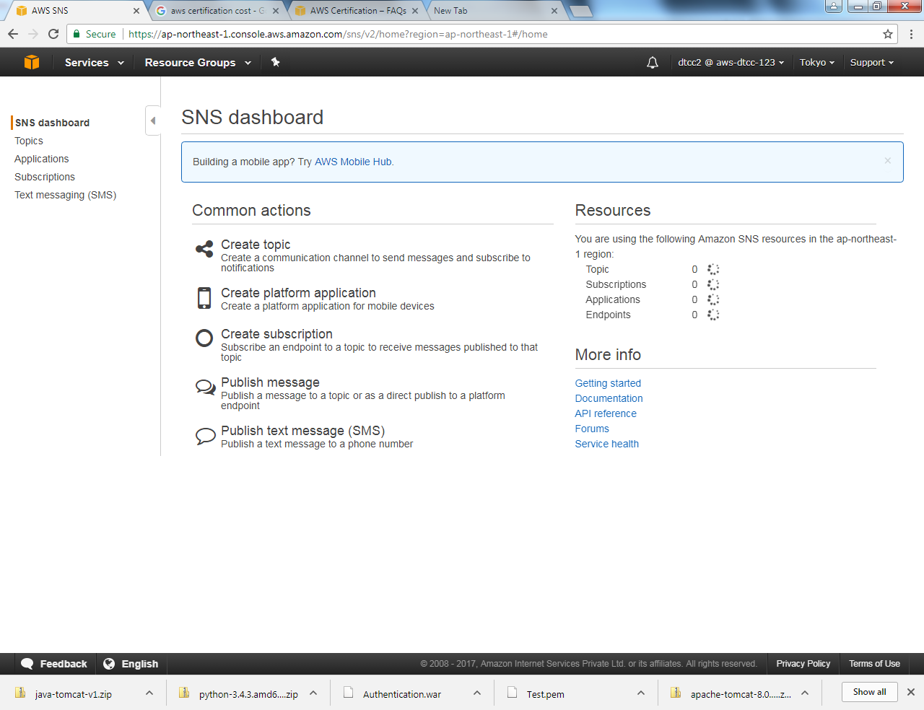

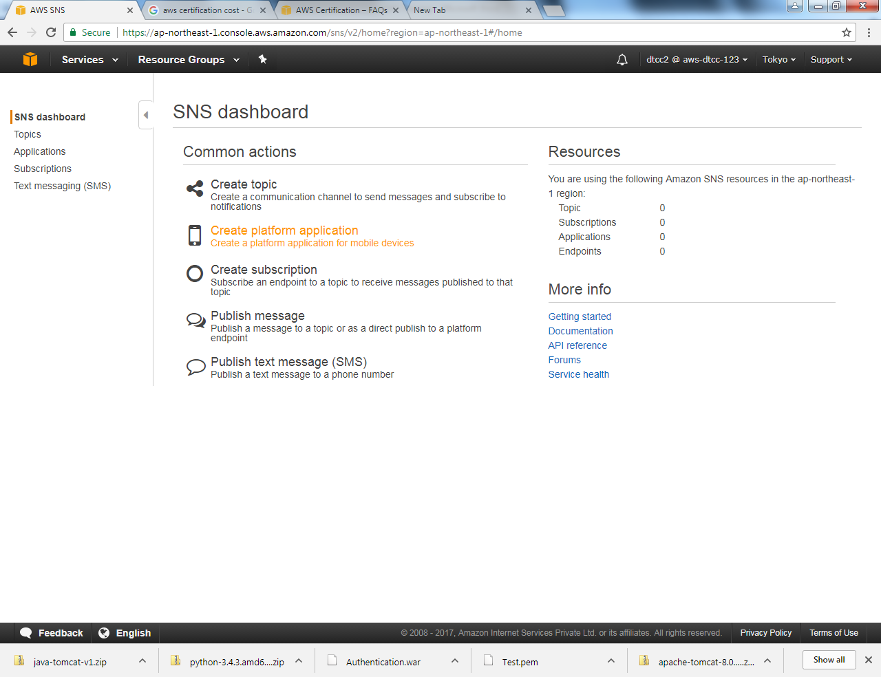

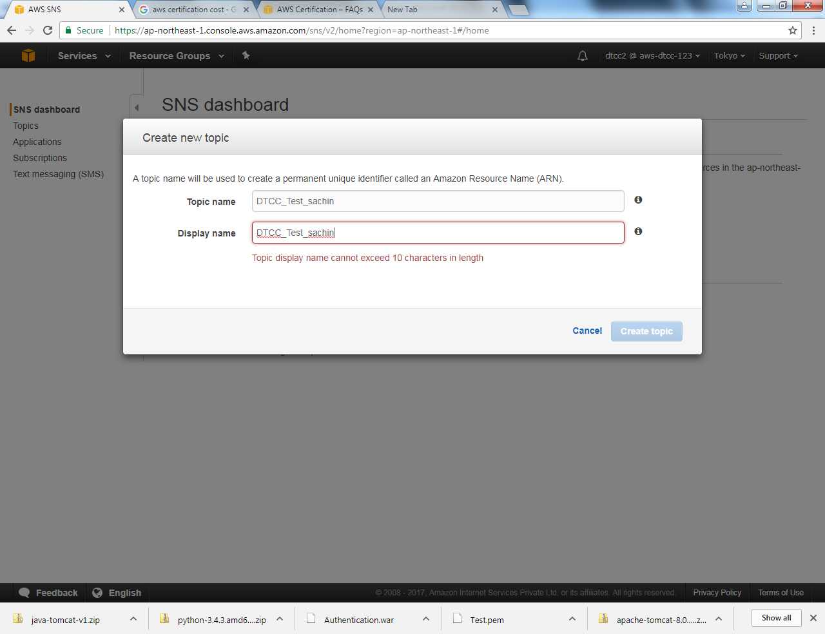

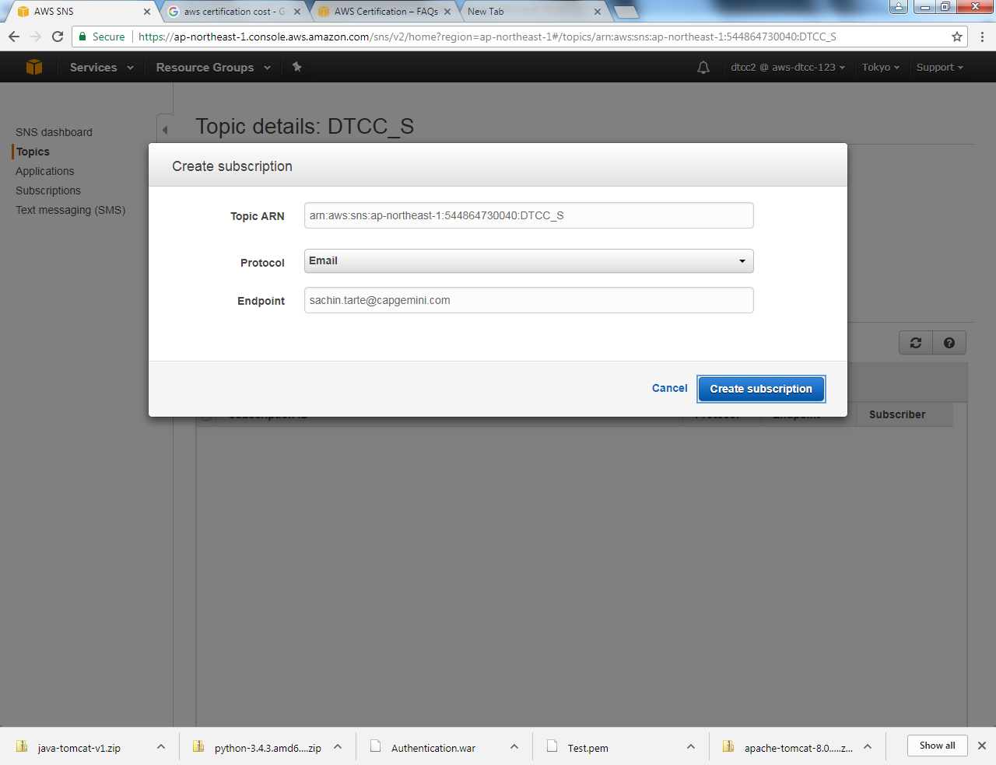

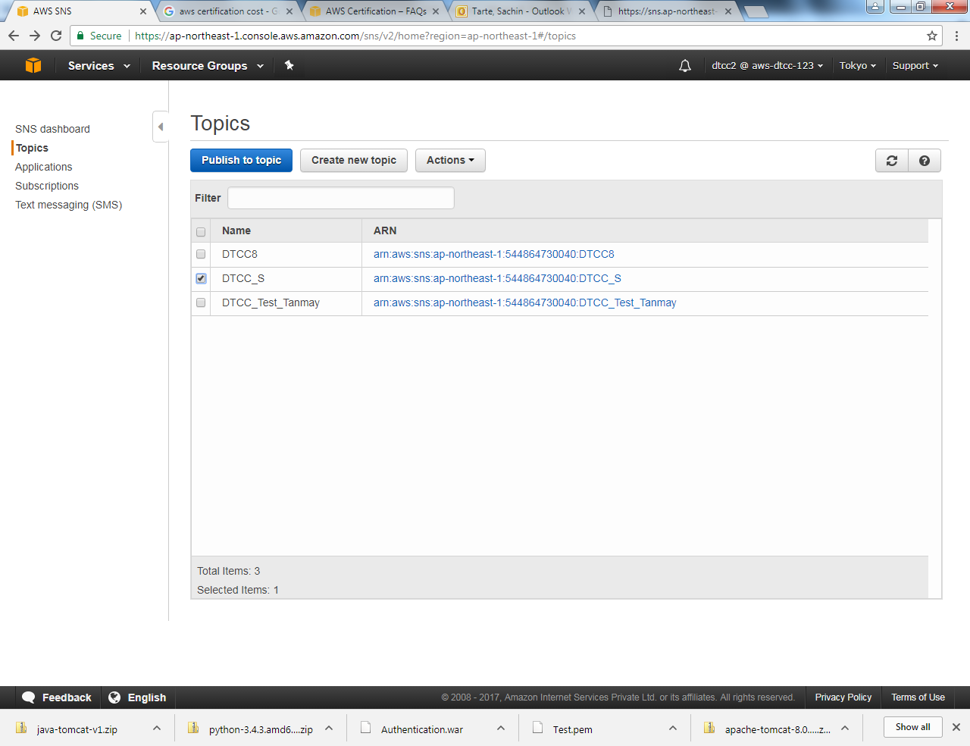

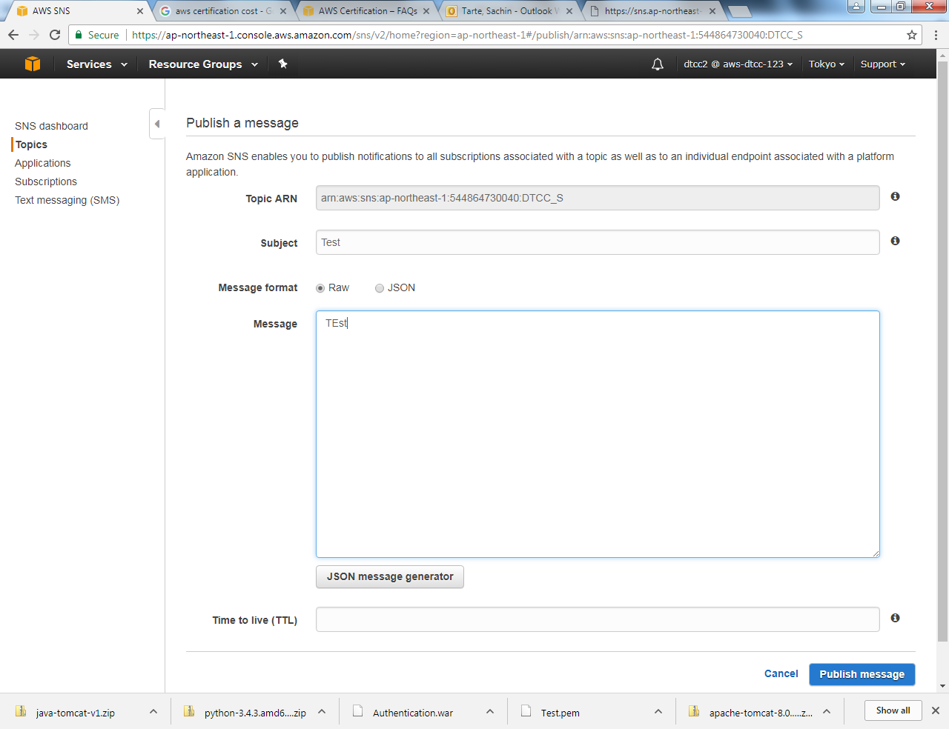

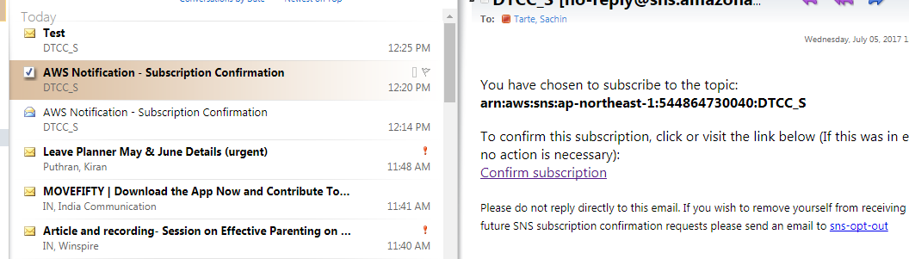

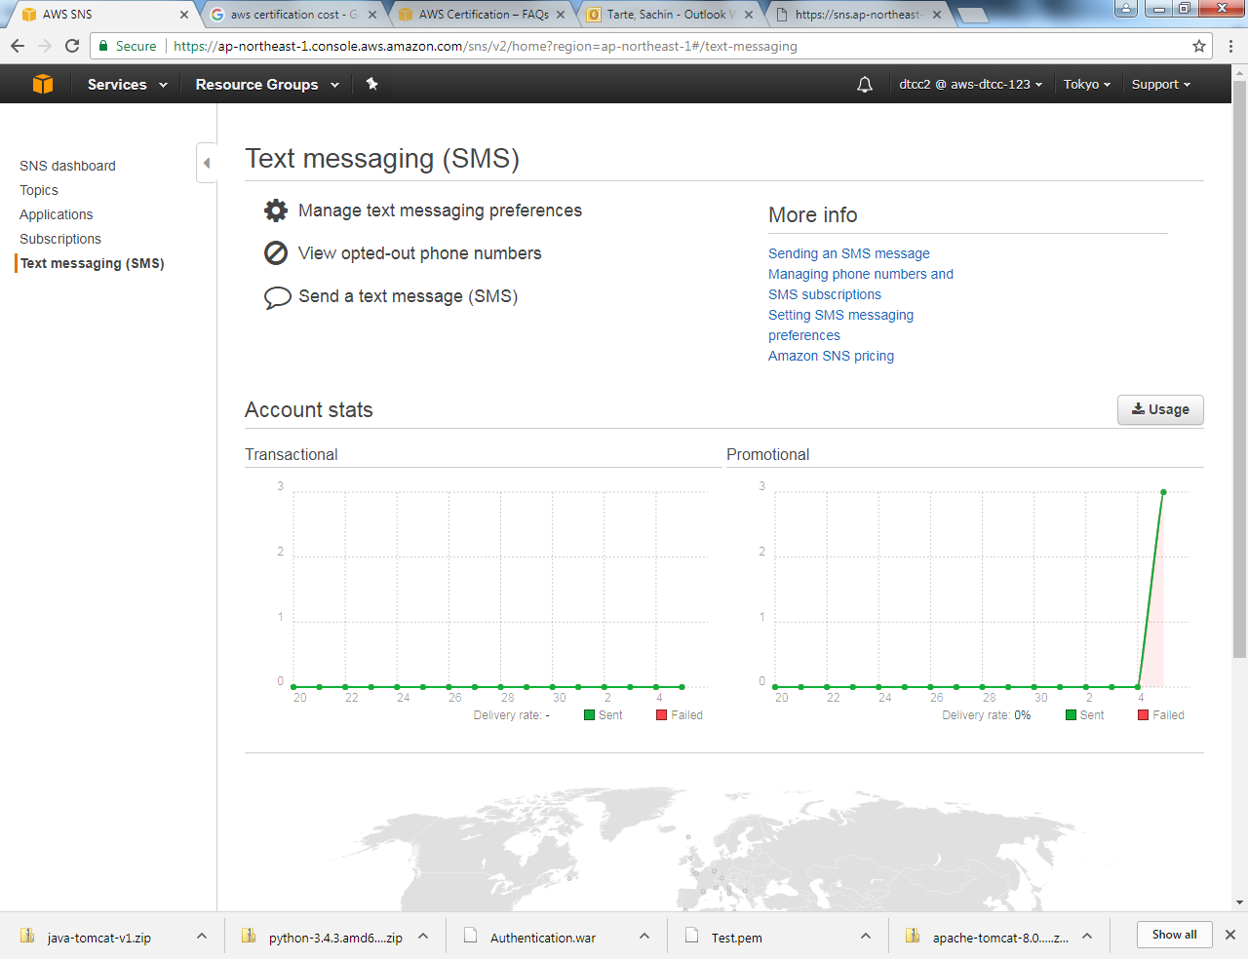

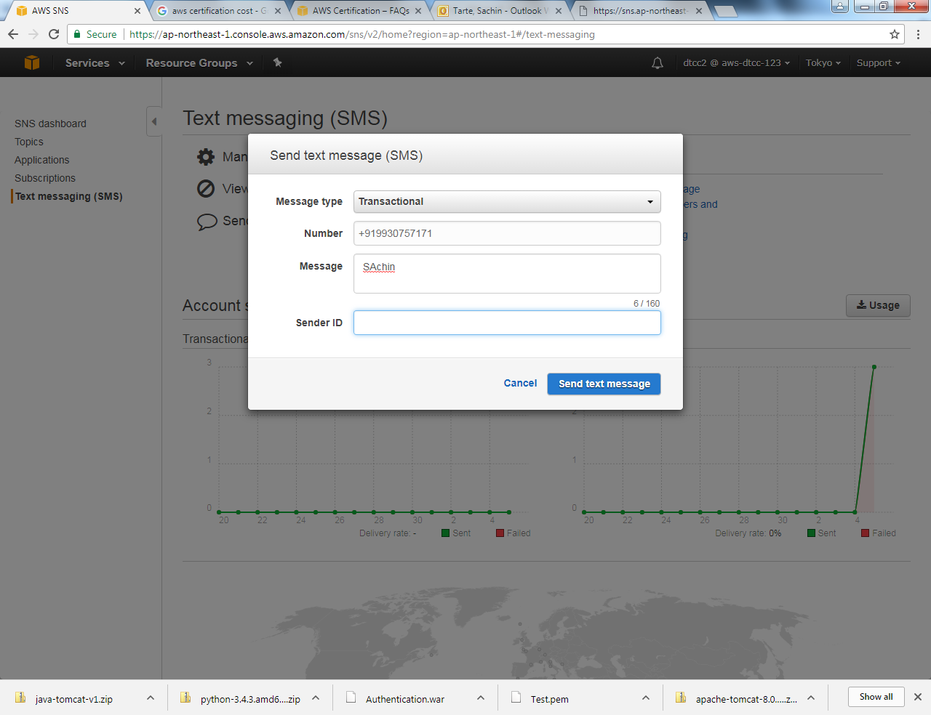

RDS – Relational Database Service (For Pr)

Adish Deshpande – Interview Preparation on Spring & Java.

International Certification –

Udeme –